CHAPERONES
If you feel you would like a chaperone present during your consultation or examination, please inform the Reception staff, Doctor or Nurse, who will happily arrange this for you.
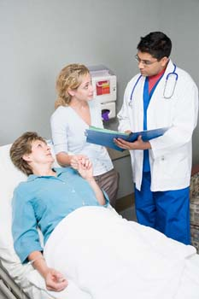
All our Chaperones are trained and are DBS checked.

